MEMBERSHIP APPLICATION FORM

Mtaji sacco society limited
P.O. Box 69422-00400
Nairobi, Kenya

I hereby make an application for membership and agree to abide by the By-Laws and amendments thereof in the said sacco

PART A. PERSONAL DETAILS

Full Name…………………………………………………………………………………………………….………………………………………..

Date of Birth……………………………………….. National ID No/ PP No.……………………………………………………………

Occupation……………………………………………… Name of Employer………………………………………………………………..

Business location………………………………………………………………………………………………………………………..

Postal Address P. O. Box ………………..Postal Code………………. Town………………………………….……………
Email Address 1…………………………………………………………………………………………………………………………
Tel/cell Phone Nos. 1.…………………………………………….. 2..………………………………………………………………………… Contact Person Details

Name ………………………... .Relationship …………….……………………………….

Postal Address ………………………Postal Code………………………. Town……………………………………………………………

Tel/Cell Phone No.………………………………………………... I.D. NO.……………………………………………………...

Attached the following;
1. Copy of your national ID Card/Passport
2. One recent Coloured Passport Size Photograph
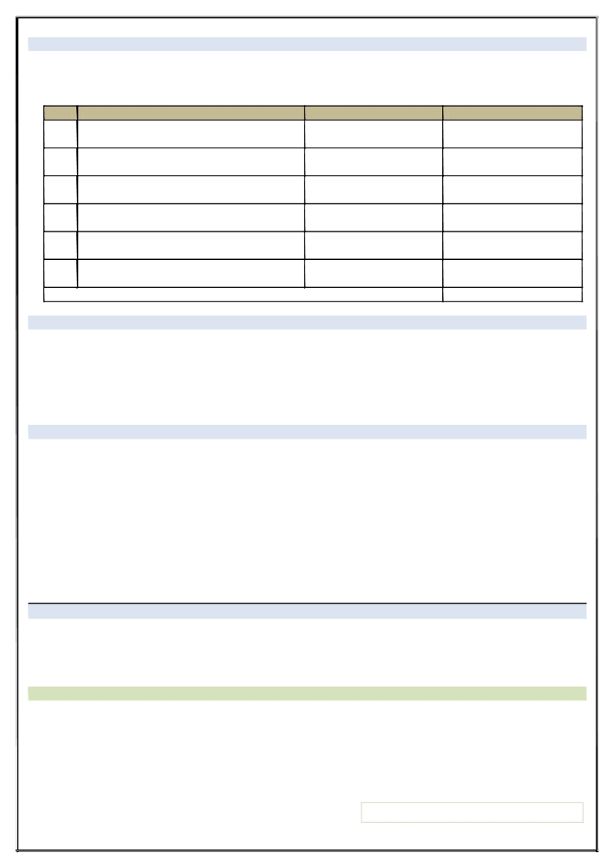

PART B. NOMINEE /BENEFICIARY DETAILS

I ………………………………………………………………………hereby nominate the following nominee(s) to inherit my shares, savings and any other funds in the said society in the following manner:

Name of Nominee Relationship Percentage (%)of share
1.
2.
3.
4.
5.
6.

Total 100%

PART C. BANKING DETAILS
Account Name……………………………………………………………Account Number………………………………………………….. Bank Name………………………………………………………………..Branch Name……………………………………………………… Bank Code………………………………………………………………... Branch Code……………………………………………………….
PART D. MEMBER’S DECLARATION
I declare that the foregoing information I have provided herein is true and complete. I agree to abide by the Society’s By-Laws, Laws, Rules and Regulations that govern the operations of the Society.

Full Name……………………………………………………………………………………………………………………………………………….

Signature ………………………………………... .Date……………………………………………………………………….

WITNESSED BY:…………………………………………………………………………… Member Number/ PF No……………………

SIGNATURE OF WITNESS……………………………………………………………….Date ……………………………………………….

FOR OFFICIAL USE ONLY
Membership / Entrance Fee Kes. 2,000/- (Payable once)
Share Capital Kes. 5,000/- (Payable at once )

Membership Number…………………………………… Date of Admission to Membership…………………………………….

CHAIRMAN
I, the undersigned have checked the accuracy and completion of the Membership Application Form.

Name…………………………………………………………………………………………………………..
Signature ………………………………………... .Date…………………………………………

